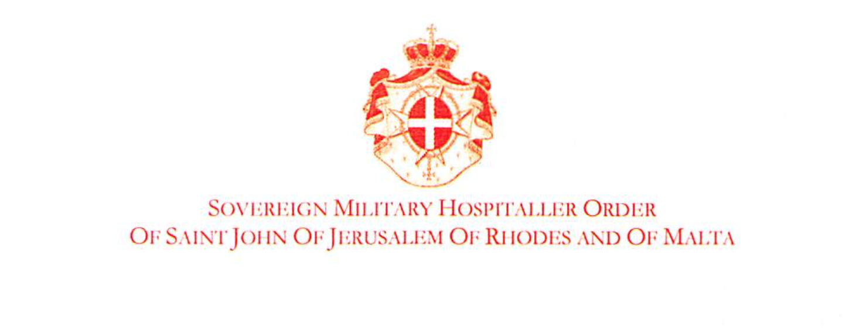

Fifth Informal Thematic Session on « Smuggling of migrants, trafficking in persons and in contemporary forms of slavery, including appropriate identification, protection and assistance to migrants and trafficking victims »

Vienna, 4 September 2017

Statement by Professor Michel Veuthey
Ambassador of the Sovereign Order of Malta
to Monitor and Combat Trafficking in Persons

The Order of Malta would like to thank the organizers of this extremely interesting Fifth Informal Thematic Session.

We reaffirm the Order’s commitment to contribute to reduce vulnerabilities of migrants and to protect them, especially victims of human trafficking.

The Order of Malta is about to reinforce its efforts to address migrant vulnerability through its international diplomatic network, on the multilateral level, as well as through its bilateral Ambassadors in 106 countries. In addition, we propose social and humanitarian actions conducted by our National Associations and our worldwide relief agency "Malteser International".

The Order would like to continue to listen to other stakeholders, such as yourselves, to learn from your best practices. We invite cooperation in order to contribute to better protect migrants.

We would like to reaffirm the relevant rules of international, regional law, as well as universal religious values protecting human life and dignity.

Mr. Chairman, allow me to leave you with a question: could we use the opportunities of the following anniversaries in 2018 to highlight the plight of victims of human trafficking and the pressing need to assist and protect them:

- The 20th anniversaries of the Rome Statute of the International Criminal Court and of the Guiding Principles on the protection of IDPs

- The 70th anniversary of the adoption of the Universal Declaration on Human Rights.

Thank you, Mr. Chairman.

